**The South Australia**

Presentation is made by

Vira Lytvyn

**Lviv 2011**

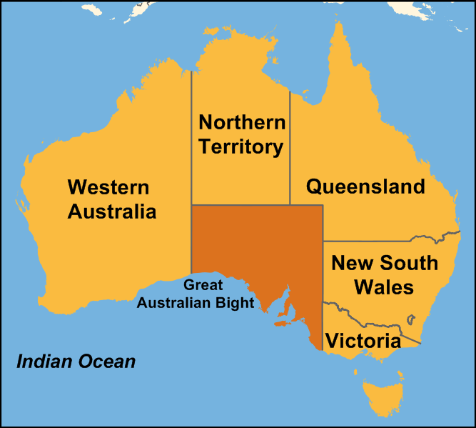**South Australia** (abbreviated as **SA**) is a [state](http://en.wikipedia.org/wiki/States_and_territories_of_Australia) of [Australia](http://en.wikipedia.org/wiki/Australia) in the southern central part of the country. It covers some of the most arid parts of the continent. It is the fourth largest of Australia's six states and two territories.

South Australia shares borders with all of the mainland states and the [Northern Territory](http://en.wikipedia.org/wiki/Northern_Territory). It is bordered to the west by [Western Australia](http://en.wikipedia.org/wiki/Western_Australia), to the north by the Northern Territory, to the north-east by [Queensland](http://en.wikipedia.org/wiki/Queensland), to the east by [New South Wales](http://en.wikipedia.org/wiki/New_South_Wales), to the south-east by [Victoria](http://en.wikipedia.org/wiki/Victoria_(Australia)), and to the south by the [Great Australian Bight](http://en.wikipedia.org/wiki/Great_Australian_Bight) and the [Indian Ocean](http://en.wikipedia.org/wiki/Indian_Ocean).

Official settlement began on 28 December 1836, when the colony was proclaimed at [The Old Gum Tree](http://en.wikipedia.org/wiki/The_Old_Gum_Tree) by Governor [John Hindmarsh](http://en.wikipedia.org/wiki/John_Hindmarsh).

The terrain consists largely of arid and semi-arid rangelands, with several low [mountain ranges](http://en.wikipedia.org/wiki/Mountain_range). The highest point in the state is [Mount Woodruff](http://en.wikipedia.org/wiki/Mount_Woodroffe) (1,435 meters (4,708 ft)).The south-western portion of the state consists of the sparsely inhabited [Nullarbor Plain](http://en.wikipedia.org/wiki/Nullarbor_Plain" \o "Nullarbor Plain), fronted by the cliffs of the [Great Australian Bight](http://en.wikipedia.org/wiki/Great_Australian_Bight). Features of the coast include [Spencer Gulf](http://en.wikipedia.org/wiki/Spencer_Gulf) and the [Eyre and Yorke Peninsulas](http://en.wikipedia.org/wiki/Eyre_Yorke_Block) that surround it.

The southern part of the state has a [Mediterranean climate](http://en.wikipedia.org/wiki/Mediterranean_climate).

South Australia is a [constitutional monarchy](http://en.wikipedia.org/wiki/Constitutional_monarchy) with the [Queen of Australia](http://en.wikipedia.org/wiki/Elizabeth_II_of_the_United_Kingdom) as Sovereign,

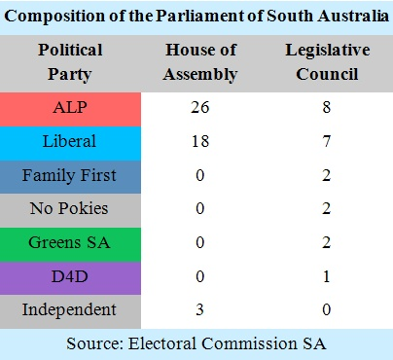and the [Governor of South Australia](http://en.wikipedia.org/wiki/Governor_of_South_Australia) as her representative. It is a state of the [Commonwealth of Australia](http://en.wikipedia.org/wiki/Commonwealth_of_Australia). Its bicameral parliament consists of a [House of Assembly](http://en.wikipedia.org/wiki/South_Australian_House_of_Assembly) (lower house) and a [Legislative Council](http://en.wikipedia.org/wiki/South_Australian_Legislative_Council) (upper house), with [legislative elections](http://en.wikipedia.org/wiki/South_Australian_legislative_elections) held every four years. The current [Premier of South Australia](http://en.wikipedia.org/wiki/Premier_of_South_Australia)is [Jay Weatherill](http://en.wikipedia.org/wiki/Jay_Weatherill), a member of the [Australian Labor Party](http://en.wikipedia.org/wiki/Australian_Labor_Party).

[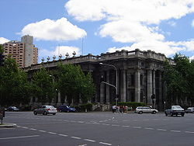](http://en.wikipedia.org/wiki/File:Adelaide_parliament_house.JPG)Initially, the [Governor of South Australia](http://en.wikipedia.org/wiki/Governor_of_South_Australia) held almost total power, derived from the Letters Patent of the Imperial Government to create the colony. He was only accountable to the British [Colonial Office](http://en.wikipedia.org/wiki/Colonial_Office), and thus democracy did not exist in the colony. A new body was created to advise the governor on the administration of South Australia in 1843 called the Legislative Council. It consisted of three representatives of the British Government and four colonists appointed by the governor. The governor retained total executive power.

[*Parliament House, Adelaide*](http://en.wikipedia.org/wiki/Parliament_House,_Adelaide)

A majority of the state's population lives within Adelaide's metropolitan area which had an estimated population of 1,158,259 in 2007 (70.3% of the state). Other significant population centers include [Mount Barker](http://en.wikipedia.org/wiki/Mount_Barker,_South_Australia) , [Mount Gambier](http://en.wikipedia.org/wiki/Mount_Gambier,_South_Australia), [Whyalla](http://en.wikipedia.org/wiki/Whyalla), [Murray Bridge](http://en.wikipedia.org/wiki/Murray_Bridge,_South_Australia), [Port Augusta](http://en.wikipedia.org/wiki/Port_Augusta,_South_Australia), [Port Pirie](http://en.wikipedia.org/wiki/Port_Pirie), [Port Lincoln](http://en.wikipedia.org/wiki/Port_Lincoln), and [Victor Harbor](http://en.wikipedia.org/wiki/Victor_Harbor,_South_Australia).

South Australia's economy includes the following major industries: meat and meat preparations, wheat, wine, wool and sheepskins, machinery, metal and metal manufactures, fish and crustaceans, road vehicles and parts, and petroleum products. Other industries, such as education and defence technology, are of growing importance. South Australia's economy relies on exports more than any other state in Australia.

[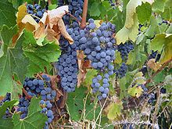](http://en.wikipedia.org/wiki/File:Clare_Valley_Cabernet_Sauvignon.jpg)The principal industries and exports of South Australia are wheat, wine and wool.  More than half of Australia's wines are produced in the South Australian wine regions which principally include: [Barossa Valley](http://en.wikipedia.org/wiki/Barossa_Valley_(wine)), [Clare Valley](http://en.wikipedia.org/wiki/Clare_Valley), [McLaren Vale](http://en.wikipedia.org/wiki/McLaren_Vale), [Coonawarra](http://en.wikipedia.org/wiki/Coonawarra), the [Riverland](http://en.wikipedia.org/w/index.php?title=Riverland_(wine)&action=edit&redlink=1) and the [Adelaide Hills](http://en.wikipedia.org/wiki/Adelaide_Hills).

*[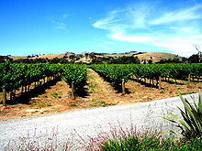](http://en.wikipedia.org/wiki/File:McLaren_Vale_vineyard.jpg)Cabernet Sauvignon from the Clare Valley.*

*Vineyard in McLaren Vale.*

[*Flinders Medical Centre*](http://en.wikipedia.org/wiki/Flinders_Medical_Centre)*. Health care and social assistance is the largest*[*ABS*](http://en.wikipedia.org/wiki/Australian_bureau_of_statistics)*defined employment sector in South Australia*

[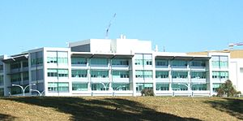](http://en.wikipedia.org/wiki/File:Flinders_building.jpg)South Australia's largest employment sector is health care and social assistance.

[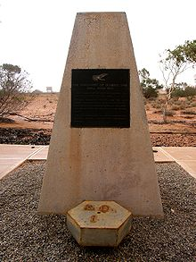](http://en.wikipedia.org/wiki/File:Olympic_dam_rd1.jpg)South Australia possesses the world's single largest known deposit of [uranium](http://en.wikipedia.org/wiki/Uranium), at the [Olympic Dam](http://en.wikipedia.org/wiki/Olympic_Dam,_South_Australia) mine. Olympic Dam contains 40% of the world's known uranium reserves. The Olympic Dam mine is also the world's fourth-largest remaining copper deposit, and the world's fifth largest gold deposit.

[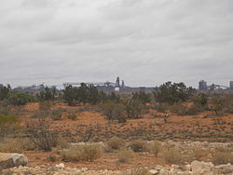](http://en.wikipedia.org/wiki/File:OlympicDamMainShafts.JPG)  
*Main shafts, 2009*

*Monument at the discovery hole of Olympic Dam, RD1*

  Education is compulsory for all children until age 17, unless they are working or undergoing other training. The majority of students stay on to complete their [South Australian Certificate of Education](http://en.wikipedia.org/wiki/South_Australian_Certificate_of_Education) **(SACE).** School education is the responsibility of the South Australian government, but the public and private education systems are funded jointly by it [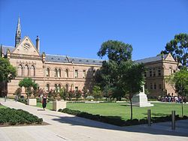](http://en.wikipedia.org/wiki/File:University_of_Adelaide.jpg)and the [Commonwealth Government](http://en.wikipedia.org/wiki/Government_of_Australia).

There are three public and three private universities in South Australia. The three public universities are The [University of Adelaide](http://en.wikipedia.org/wiki/University_of_Adelaide) (established 1874), The [Flinders University of South Australia](http://en.wikipedia.org/wiki/Flinders_University_of_South_Australia) (est. 1966), and The [University of South Australia](http://en.wikipedia.org/wiki/University_of_South_Australia) (est. 1991).

[*University of Adelaide*](http://en.wikipedia.org/wiki/University_of_Adelaide)*from*[*North Terrace*](http://en.wikipedia.org/wiki/North_Terrace,_Adelaide)*.*

[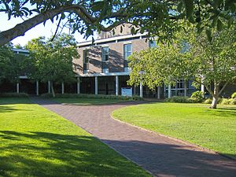](http://en.wikipedia.org/wiki/File:Flinders_humanities_courtyard.jpg)

*View of Flinders University main campus, with central plaza and lakeside area visible*.

[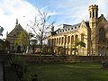](http://en.wikipedia.org/wiki/File:UofAdelaide-BonythonHall&Conservatorium-front-Aug08.jpg)The three private universities are [Carnegie Mellon University - Australia](http://en.wikipedia.org/wiki/Carnegie_Mellon_University_-_Australia) (est.2006), [University College London](http://en.wikipedia.org/wiki/University_College_London)'s School of Energy and Resources (Australia), and [Cranfield University](http://en.wikipedia.org/wiki/Cranfield_University" \o "Cranfield University). All six have their main campus in the Adelaide metropolitan area: Adelaide and UniSA on [North Terrace](http://en.wikipedia.org/wiki/North_Terrace) in the [city](http://en.wikipedia.org/wiki/Adelaide_city_centre); CMU, UCL and Cranfield are co-located on [Victoria Square](http://en.wikipedia.org/wiki/Victoria_Square,_Adelaide) in the city, and Flinders at [Bedford Park](http://en.wikipedia.org/wiki/Bedford_Park,_South_Australia).

[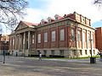](http://en.wikipedia.org/wiki/File:UofAdelaide-BarrSmithLibrary-Aug08.jpg)

*The*[*Barr Smith Library*](http://en.wikipedia.org/wiki/Barr_Smith_Library)*.*

[*Bonython*](http://en.wikipedia.org/wiki/John_Langdon_Bonython)*Hall & the*[*Elder*](http://en.wikipedia.org/wiki/Thomas_Elder)[*Conservatorium*](http://en.wikipedia.org/wiki/Elder_Conservatorium) *of Music (viewed from North Terrace).*

*[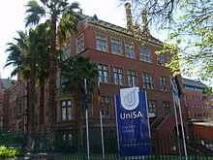](http://en.wikipedia.org/wiki/File:UniSA_City_East_Campus.jpg) UniSA City East Campus, Brookman Building*

[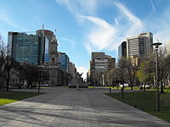](http://en.wikipedia.org/wiki/File:VictoriaSquare_North.JPG)

*Carnegie Mellon University,**Victoria Square, Adelaide*

*Motto:* ***"My heart is in the work"*** *(Andrew Carnegie)*

[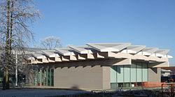](http://en.wikipedia.org/wiki/File:Cranfield_University_C4D_building.jpg)

*[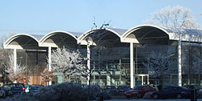](http://en.wikipedia.org/wiki/File:Cranfield_University_Library.jpg)C4D Building, the Centre for*

*Creative Competitive Design,*

*opened 2010*

*Cranfield University Library*

*[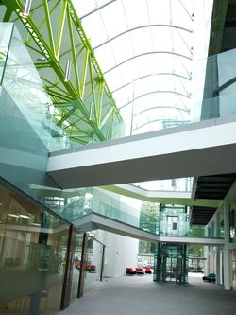](http://en.wikipedia.org/wiki/File:2008_05_28_Cranfield_Health_inside.JPG)The new School, 'Cranfield Health' interior*

[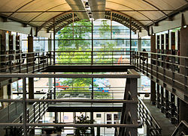](http://en.wikipedia.org/wiki/File:2008_05_28_Cranfield_Health_from_Library.jpg)

*The new School, 'Cranfield Health' prior to official opening, May 2008, viewed from the Library*

[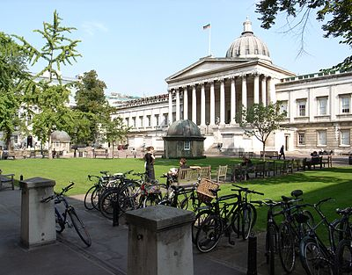](http://en.wikipedia.org/wiki/File:University_College_London_-quadrant-11Sept2006_(1).jpg)

*A summertime view from the South-Western corner of the quadrangle towards the UCL main building on Gower Street*

[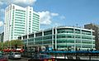](http://en.wikipedia.org/wiki/File:University_College_Hospital_-_New_Building_-_London_-_020504.jpg)

[*University College Hospital*](http://en.wikipedia.org/wiki/University_College_Hospital)

[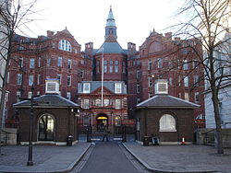](http://en.wikipedia.org/wiki/File:UCL_Gower_Street.jpg) *The Cruciform Building on*[*Gower Street*](http://en.wikipedia.org/wiki/Gower_Street_(London))*houses the preclinical facilities of the UCL Medical School;*

[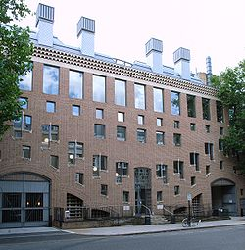](http://en.wikipedia.org/wiki/File:School_of_Slavonic_and_East_European_Studies.jpg)

*16 Taviton Street (home to the*[*UCL School of Slavonic and East European Studies*](http://en.wikipedia.org/wiki/UCL_School_of_Slavonic_and_East_European_Studies)*)*

The public universities also have other campuses in the metropolitan area, around the state, inter-state, and overseas.

[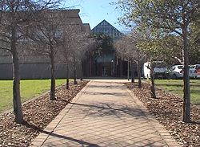](http://en.wikipedia.org/wiki/File:TAFE_SA_Tea_Tree_Gully.jpg)

Tertiary vocational education is provided by [**TAFE** South Australia](http://en.wikipedia.org/wiki/TAFE_South_Australia) colleges throughout the state.

*Tea Tree Gully TAFE campus.*

**Sports**

[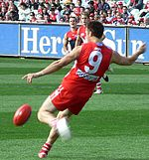](http://en.wikipedia.org/wiki/File:Aussie_rules_kicking.jpg)[Australian rules football](http://en.wikipedia.org/wiki/Australian_rules_football) is the most popular spectator sport in South Australia, with South Australians having the highest attendance rate in Australia.

[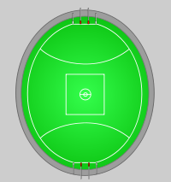](http://en.wikipedia.org/wiki/File:AFL_stadium.svg) *Typical*[*Australian rules football playing field*](http://en.wikipedia.org/wiki/Australian_rules_football_playing_field)*.*

*Precise field and goal kicking using the oval shaped ball is the most important skill in Australian rules.*

[](http://en.wikipedia.org/wiki/File:SA_Redbacks_logo.png)[Cricket](http://en.wikipedia.org/wiki/Cricket) is the most popular summer sport in South Australia and attracts big crowds. South Australia has a cricket team, the [Southern Redbacks](http://en.wikipedia.org/wiki/Southern_Redbacks), who play at [Adelaide Oval](http://en.wikipedia.org/wiki/Adelaide_Oval) in the[Adelaide Park Lands](http://en.wikipedia.org/wiki/Adelaide_Park_Lands) during the summer;

*West End Redbacks*

**Association football**

South Australia's [Association Football](http://en.wikipedia.org/wiki/Association_Football) (soccer) team in the [A-League](http://en.wikipedia.org/wiki/A-League) is [Adelaide United F.C.](http://en.wikipedia.org/wiki/Adelaide_United_F.C.) The club's home ground is [Hindmarsh Stadium](http://en.wikipedia.org/wiki/Hindmarsh_Stadium" \o "Hindmarsh Stadium).

[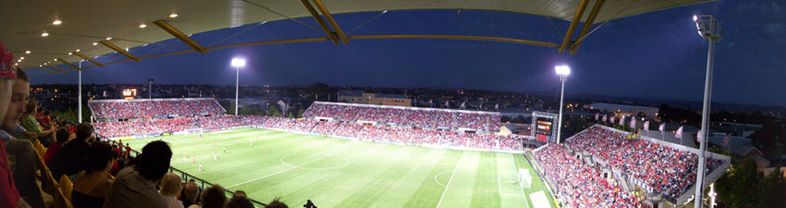](http://en.wikipedia.org/wiki/File:Adl_utd_stadium.jpg)

*Panorama View of Hindmarsh Stadium*,

[Adelaide United](http://en.wikipedia.org/wiki/Adelaide_United) vs [Perth Glory](http://en.wikipedia.org/wiki/Perth_Glory) in 2009 Basketball also has a big following in South Australia, with the [Adelaide 36ers](http://en.wikipedia.org/wiki/Adelaide_36ers) playing out of an 8,070 seat stadium in [Findon](http://en.wikipedia.org/wiki/Findon,_South_Australia).

[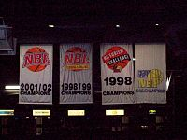](http://en.wikipedia.org/wiki/File:Adelaide_36ers_NBL_Championship_banners.jpg)[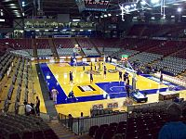](http://en.wikipedia.org/wiki/File:Brett_Maher_Court_023.jpg)

*The Brett Maher Court*

*Adelaide 36ers NBL Championship banners*

[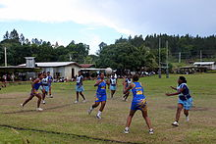](http://en.wikipedia.org/wiki/File:Natalei_netball.jpg)Fifty-nine percent of South Australian children take part in organised sports. For boys, soccer has the highest participation rate (22%), followed by swimming (16%). For girls [netball](http://en.wikipedia.org/wiki/Netball) is most popular (18%), also followed by swimming (16%).

*A pass takes place during a women's* [*netball game in Fiji*](http://en.wikipedia.org/wiki/Netball_in_Fiji)*.*

[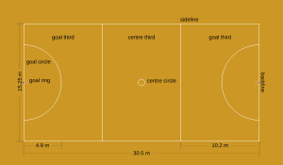](http://en.wikipedia.org/wiki/File:Netball-edit2.svg)[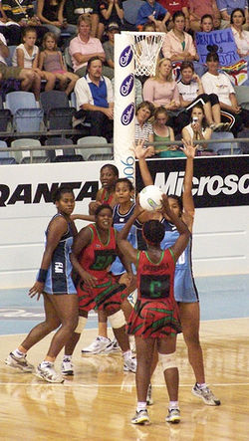](http://en.wikipedia.org/wiki/File:MalawiFijiNetball.jpg)

A netball court's dimensions. The court is divided into thirds and shooting circles are at each end.

[Malawi](http://en.wikipedia.org/wiki/Malawi_national_netball_team) (red) playing [Fiji](http://en.wikipedia.org/wiki/Fiji_national_netball_team) (blue) at the [2006 Commonwealth Games](http://en.wikipedia.org/wiki/2006_Commonwealth_Games)

**The most interesting about Australia**

[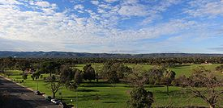](http://en.wikipedia.org/wiki/File:South_terrace_adelaide.jpg)[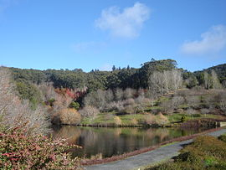](http://en.wikipedia.org/wiki/File:Mt_Lofty_Botanic_Gardens.JPG) *Looking out over the Mount Lofty Botanic Gardens lower lake*

*A view of the Adelaide Hills from South Terrace Adelaide*

*[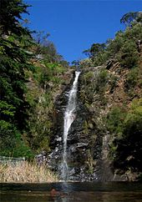](http://en.wikipedia.org/wiki/File:Waterfall_Gully_waterfall.jpg)*

*The*[*Waterfall Gully*](http://en.wikipedia.org/wiki/Waterfall_Gully,_South_Australia)*waterfall in the Adelaide Foothills*

[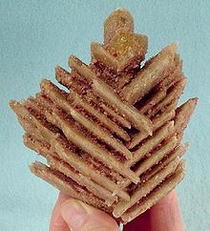](http://en.wikipedia.org/wiki/File:Gypsum-137964.jpg)

*Unusual herringbone crystals of*[*evaporite*](http://en.wikipedia.org/wiki/Evaporite)[*gypsum*](http://en.wikipedia.org/wiki/Gypsum)*,*

*from Sinclairs Gap Lake,*

*Middleback Range,*

*Eyre peninsula.*

[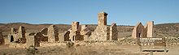](http://en.wikipedia.org/wiki/File:Kanyaka_homestead.jpg)

*Abandoned Kanyaka homestead between Quorn and Hawker.*

*[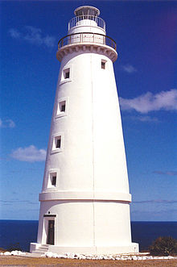](http://en.wikipedia.org/wiki/File:Cape_Willoughby_Lighthouse.jpg) Arid land in the Flinders Ranges[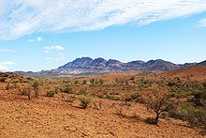](http://en.wikipedia.org/wiki/File:Flinders_ranges_pastoral_land.JPG)*

*Cape Willoughby Lighthouse*

[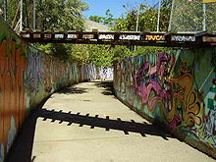](http://en.wikipedia.org/wiki/File:SECOND_CREEK_ADELAIDE.jpg)

*Second Creek near St Peters, showing its current concrete form*

[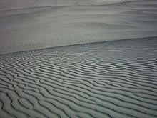](http://en.wikipedia.org/wiki/File:Little_Sahara.jpg)

[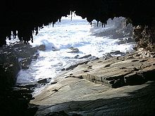](http://en.wikipedia.org/wiki/File:Admiral's_Arch.jpg)

*Little Sahara*

*Admiral's Arch*

[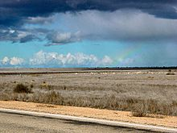](http://en.wikipedia.org/wiki/File:Nullarbor_Plain_Rainbow_DSC04547.JPG)[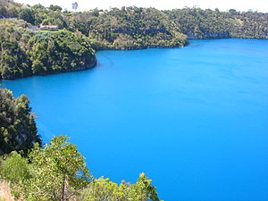](http://en.wikipedia.org/wiki/File:Blue_Lake,_Mount_Gambier.jpg)

*Blue Lake, Mount Gambier*

*Rainbow over*

*the Nullarbor Plain - also known as the road sign of the Gods*

[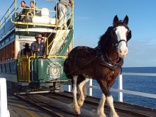](http://en.wikipedia.org/wiki/File:20040610_Victor_Harbor_Tramway.jpg)

[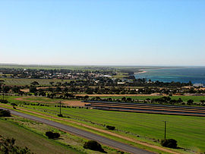](http://en.wikipedia.org/wiki/File:Ardrossan.jpg)

*Ardrossan Jetty*

*[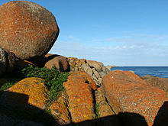](http://en.wikipedia.org/wiki/File:20040610_Granite_Island_Boulders.jpg)Horse drawn tram on causeway between Granite Island and Victor Harbor*

*Boulders at sunset on Granite Island*

*[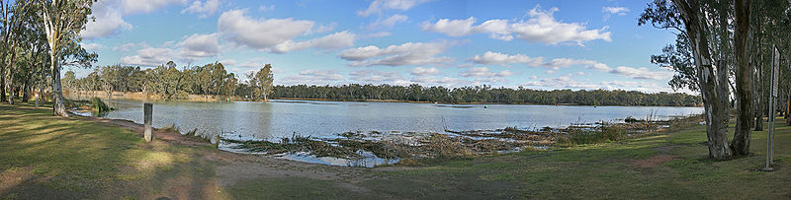](http://en.wikipedia.org/wiki/File:Confluence_of_Murray_&_Darling_Rivers,_Wentworth,_NSW,_9.7.2007.jpg)The*[*confluence*](http://en.wikipedia.org/wiki/Confluence_(geography))*of the*[*Darling*](http://en.wikipedia.org/wiki/Darling_River)*and Murray Rivers at*[*Wentworth, New South Wales*](http://en.wikipedia.org/wiki/Wentworth,_New_South_Wales)

[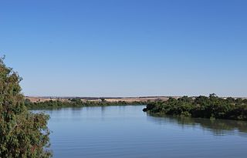](http://en.wikipedia.org/wiki/File:MurrayBridgeMurrayRiver.JPG)

*Lower course of the Murray River at*[*Murray Bridge*](http://en.wikipedia.org/wiki/Murray_Bridge)

*[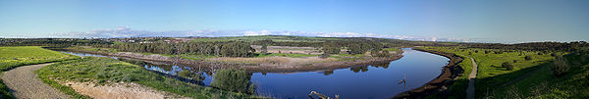](http://en.wikipedia.org/wiki/File:Onkaparinga_Estuary_1.jpg)Onkaparinga Estuary in Winter at late afternoon looking East towards [Onkaparinga River National Park](http://en.wikipedia.org/wiki/Onkaparinga_River_National_Park" \o "Onkaparinga River National Park).*

[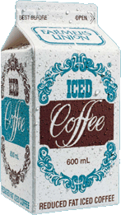](http://en.wikipedia.org/wiki/File:Iced_Coffee.GIF)

**Farmers Union Iced Coffee** is a flavored [milk](http://en.wikipedia.org/wiki/Milk) drink popular in [Australia](http://en.wikipedia.org/wiki/Australia), primarily the state of [South Australia](http://en.wikipedia.org/wiki/South_Australia), made by Foods which is now a division of Japanese brewing company [Kirin](http://en.wikipedia.org/wiki/Kirin_Brewery_Company).

[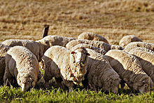](http://en.wikipedia.org/wiki/File:Sheep_eating_grass_edit02.jpg)

*Sheep grazing in rural Australia.*

*Pie floater in Adelaide*

[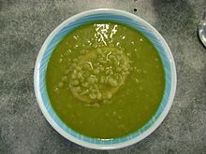](http://en.wikipedia.org/wiki/File:Pie_floater_in_Adelaide_SA.jpg)A **pie floater** is a meal available in [Australia](http://en.wikipedia.org/wiki/Australia), particularly [South Australia](http://en.wikipedia.org/wiki/South_Australia) which consists of the traditional Australian style [meat pie](http://en.wikipedia.org/wiki/Australian_meat_pie) sitting, usually inverted, in a plate of thick green [pea soup](http://en.wikipedia.org/wiki/Pea_soup). It is typically covered with [tomato sauce](http://en.wikipedia.org/wiki/Tomato_sauce) and, although subject to the taste of the individual consumer, [mint sauce](http://en.wikipedia.org/wiki/Mint_sauce) and [salt](http://en.wikipedia.org/wiki/Salt) and [pepper](http://en.wikipedia.org/wiki/Black_pepper) are also traditionally added to complement the dish. Another popular condiment is [malt vinegar](http://en.wikipedia.org/wiki/Malt_vinegar). The pie floater is typically purchased in the street from pie-carts as a late evening meal

[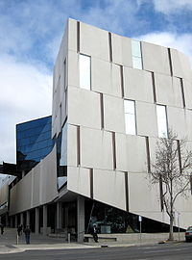](http://en.wikipedia.org/wiki/File:Hawke_Building,_UniSA.jpg) *The Hawke Building, part of the*[*UniSA*](http://en.wikipedia.org/wiki/University_of_South_Australia)*, City West Campus.*

[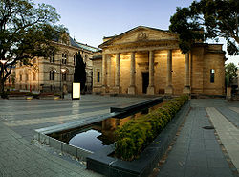](http://en.wikipedia.org/wiki/File:AGSAfront.jpg)

*The*[*Art Gallery of South Australia*](http://en.wikipedia.org/wiki/Art_Gallery_of_South_Australia)*, and part of the*[*South Australian Museum*](http://en.wikipedia.org/wiki/South_Australian_Museum)*on North Terrace.*

*[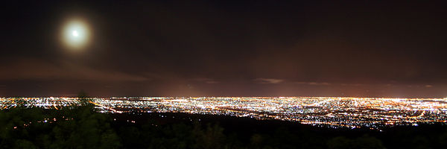](http://en.wikipedia.org/wiki/File:Mount_Lofty_View_Night.jpg)Adelaide at night, viewed from*[*Mount Lofty*](http://en.wikipedia.org/wiki/Mount_Lofty)*. The city center, not visible in the photo, is toward the far right.*

*The corner of*[*North Terrace*](http://en.wikipedia.org/wiki/North_Terrace,_Adelaide)*(right) and* [*Pulteney Street*](http://en.wikipedia.org/wiki/Pulteney_Street,_Adelaide)*(left), looking south-west from*[*Bonython Hall*](http://en.wikipedia.org/wiki/Bonython_Hall)*.*

[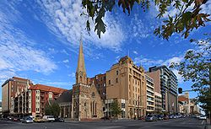](http://en.wikipedia.org/wiki/File:Adelaide_nth_tce1.8.jpg)[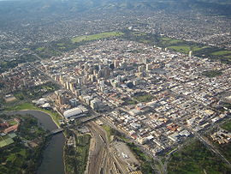](http://en.wikipedia.org/wiki/File:Adelaide_DougBarber.jpg)

*Aerial view of*[*Adelaide city centre*](http://en.wikipedia.org/wiki/Adelaide_city_centre)*in 2005*